OFFICE OF
INFORMATION
AND TECHNOLOGY

VistA Audit Solution (VAS)
User Guide
Version 2.1
February 2024

FOR INTERNAL USE ONLY

  - Revision History
Date | Version | Description | Author
02/22/2024 | 2.1 | Addition of Date Search functionality and new screenshots, rearranging of User Search functionality | Booz Allen Hamilton
11/15/2023 | 2.0 | Removal of VistA guidance, addition of Print User List functionality, updating figures | Booz Allen Hamilton
10/12/2022 | 1.0 | Initial creation of the User Guide for VistA Audit Solutions project | Booz Allen Hamilton

  - Table of Contents
1 Introduction 1
1.1 VistA Audit Solution (VAS) 1
1.2 Purpose 1
1.3 Document Disclaimer 1
2 System Summary 1
3 Getting Started 2
3.1 Access to VAS UI 2
3.2 Steps to Access 2
4 Understanding the Functionality 3
4.1 Patient Search Tab 3
4.2 Full Search 3
4.3 Partial Search 6
4.4 User Search 8
4.5 Date Range Search 11
4.6 Search Metadata Records 13
4.7 Navigate Metadata Records 13
4.8 Select/View Audit Record 15
5 Logout/Close/Exit VAS UI 16
5.1 Logout 16
5.2 Close/Exit 17
6 Troubleshooting 17
6.1 VAS is Unresponsive 17
6.2 Contact VAS Team 17
Appendix A: Acronyms and Abbreviations 18

  - List of Figures
Figure 1: PIN Prompt 2
Figure 2: VAS UI Patient Search Portal 3
Figure 3: Patient Search Overview Page 3
Figure 4: Full Name Search Button 4
Figure 5: Patient Full Search Page 4
Figure 6: Search for Patient Button 4
Figure 7: Full Search – Single Patient Result 5
Figure 8: Full Search – Multiple Patient Results 5
Figure 9: Full Search – No Patient Results 6
Figure 10: Partial Search Button 6
Figure 11: Patient Partial Search Page 6
Figure 12: Patient Partial Search - Single Patient Results 7
Figure 13: Patient Partial Search - Multiple Patient Results 8
Figure 14: Partial Search – No Patient Results 8
Figure 15: User Search 9
Figure 16: Print User List 9
Figure 17: User Name Drop-Down Menu 10
Figure 18: Metadata Records View 11
Figure 19: Date Range Search 12
Figure 20: Searching Metadata 13
Figure 21: Metadata Record Navigation 14
Figure 22: Change Rows Per Page 15
Figure 23: Ascending/Descending for Site of Data Origin 15
Figure 24: Opened Record from Metadata Record 15
Figure 25: Logout Button for VAS 16
Figure 26: Exit VAS UI 17
Figure 27: Close Browser 17
Figure 28: VA Global Address List 17

Introduction

VistA Audit Solution (VAS)
The Veterans Information System and Technology Architecture (VistA) Audit Solutions (VAS) was designed as a real-time web-based interface. VAS provides a nationwide Health Insurance Portability and Accountability Act (HIPAA) compliant Audit Tracking Solution with the ability to track and report on access logs for patients’ Personally Identifiable Information (PII)/Protected Health Information (PHI) data across all VistA instances. VAS users are Privacy Officers, Information Systems Security Officers (ISSO), and their authorized representatives who need the ability to view the log of Creation, Retrieval, Updating, and Deletion (CRUD) operations on patient information to respond to HIPAA, employee and Inspector General (IG) requests. This data originates from VistA and flows through in-memory database servers to be stored in the Veterans Affairs Enterprise Cloud (VAEC) Amazon Web Services (AWS). VAS web-based User Interface (UI) will access and display the data stored in AWS.
Authorized VAS users may view the patient data that was accessed and modified, as well as the individual that performed the actions.

Purpose
The purpose of the VAS User Guide v2.1 is to familiarize authorized users in the usage of the VAS UI.

Document Disclaimer
The appearance of external hyperlink references in this manual does not constitute endorsement by the Department of Veterans Affairs (VA) of this Web site or the information, products, or services contained therein. The VA does not exercise any editorial control over the information you may find at these locations. Such links are provided and are consistent with the stated purpose of the VA.
This document (including any enclosures, attachments, and hyperlinks) has been prepared for the exclusive use and benefit of the U.S. Department of Veterans Affairs VistA Audit Solution (VAS) and solely for the purpose for which it is provided. Unless provided express prior written consent, no part of this document should be reproduced, distributed, or communicated to any third party.
VAS endeavors to supply accurate information in this report; however, errors and omissions may occur.

System Summary
The VAS UI portal is hosted in VAEC AWS GovCloud. The system is only accessible within the VA intranet to authorized users such as Privacy Officers and Information Systems Security Officers to perform consent management tasks.

Getting Started

Access to VAS UI
This section describes the steps for accessing and understanding the VAS UI Portal functionalities.
For users to gain access to the VAS UI, users will need the following:
- VAS UI Uniform Resource Locator (URL)
- Active Personal Identification Verification (PIV) card with Personal Identification Number (PIN)
- Google Chrome or Microsoft Edge
- To be Whitelisted

Steps to Access
Take the following steps to access VAS UI via Single Sign-On Integration (SSOi) with an active PIV card.
Note: Users will only use their PIV card to access.
- Navigate to the VAS UI by entering the URL (https://var.va.gov/) into a browser (Chrome or Edge).
- When prompted, enter the PIN associated with the PIV card and click OK.
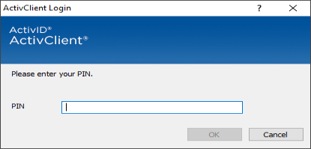
Figure 1: PIN Prompt
- VAS UI has been accessed when the screen providing Getting Started with VistA Audit Solution (VAS) displays.
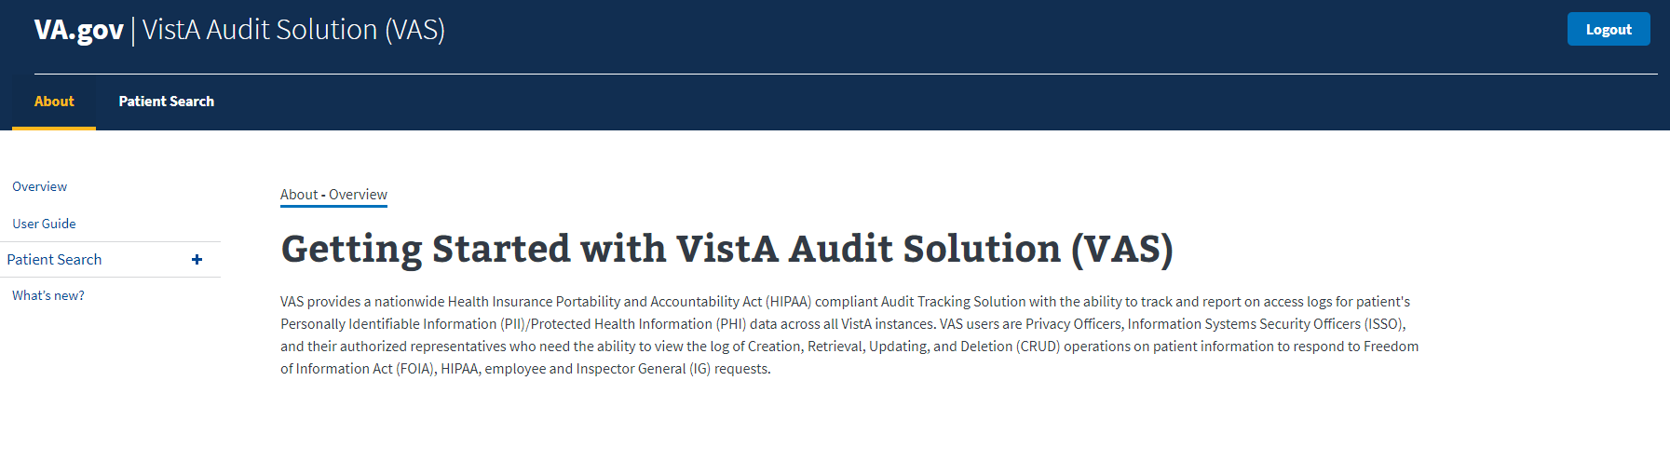
Figure 2: VAS UI Patient Search Portal

Understanding the Functionality
The VAS UI portal provides the following functionalities:
- Audited patient data accessed and modified within VistA is available for viewing.
- Viewing and identifying the actions made by the VistA user(s) for targeted audit records, including the individual that performed the actions.

Patient Search Tab
The Patient Search tab allows the user to perform a Full or Partial search for the Patient record.
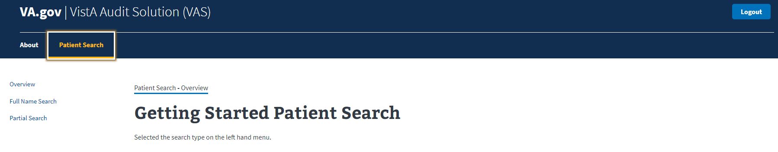
Figure 3: Patient Search Overview Page

Full Search
To conduct a Full Search in the VAS UI, users need to have:
- Access to the VAS UI
- The Patient’s full name (Last,First Middle)
  - There is no space between “Last””,””First”. If a space is entered, no record will be found. Example: SMITH,JOHN
  - Middle Name or Initial is not required.
- The Patient’s DOB (MM/DD/YYYY); or
- The Patient’s SSN (no spaces or dashes included)

Steps for Full Search
- Select the Full Name Search button on the left of the screen.

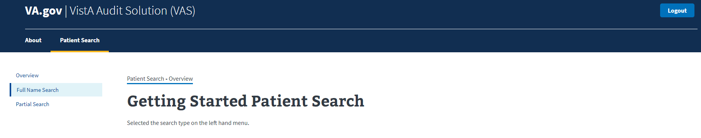
Figure 4: Full Name Search Button
The Patient Full Search window displays as seen below:
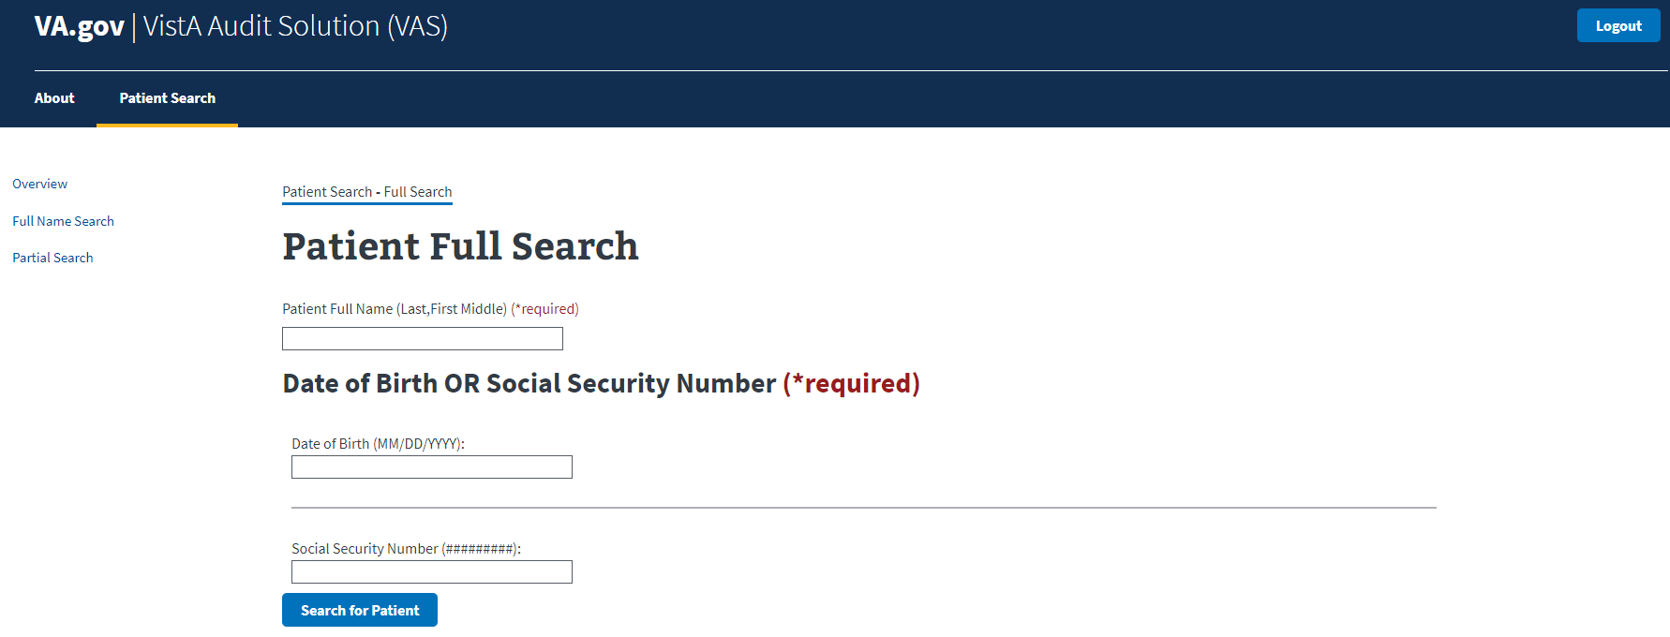
Figure 5: Patient Full Search Page
- Enter Patient Full Name (Last,First Middle) *required field
  - There is no space between “Last,First.” If a space is entered, no record will be found.
  - Middle Name or Initial is not required.
- Enter Date of Birth OR Social Security Number *required field.
  - The Search for Patient button will be enabled once all required fields are entered.
  - The Search for Patient button will remain disabled if the search criteria is entered incorrectly or left blank.
- Click the Search for Patient button.
Figure 6: Search for Patient Button

Single Patient Results – Full Search
The patient search information will display on the screen when the results are for a single record. This includes the patient’s name, date of birth, and social security number. Users will be given the option to run a User Search or a Date Range Search for the patient by selecting the respective buttons provided below the patient information as seen in Figure 7.
Figure 7: Full Search – Single Patient Result

Multiple Patient Results – Full Search
When multiple results are returned, click the Select Patient button for the desired Patient’s record.
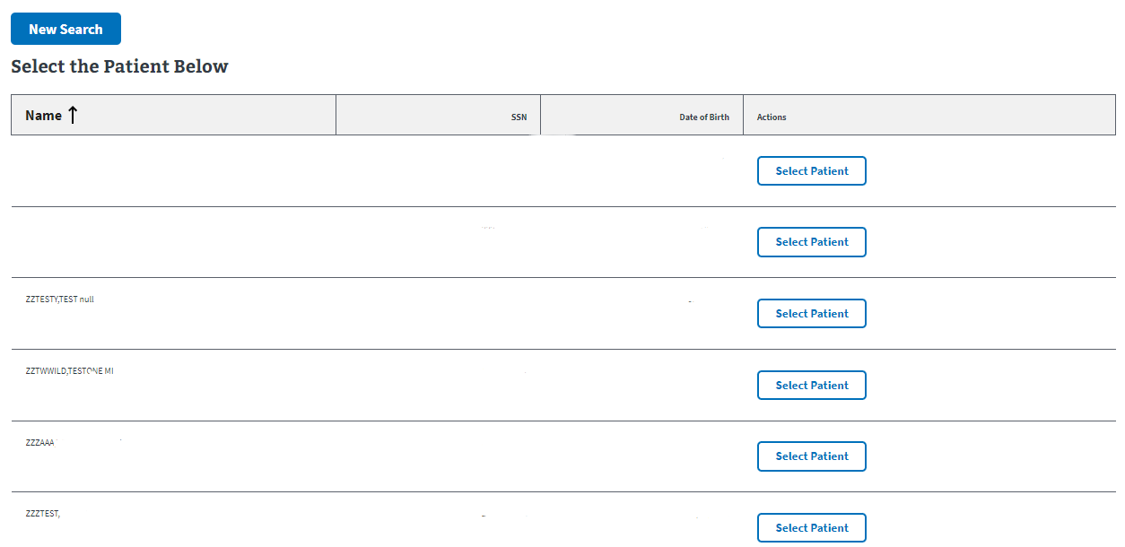
Figure 8: Full Search – Multiple Patient Results

No Patient Results – Full Search
The screen will not display any patient information if the search criteria entered cannot locate a record. The user should verify that they correctly entered the search data when performing the Full Search function. The New Search button will display in the case that the user would like to perform a new search.
Figure 9: Full Search – No Patient Results

Partial Search
To conduct a Partial Search in VAS UI, users need to have:
- Access to the VAS UI
- The first initial of the Patient’s Last Name
- Last 4 digits of the Patient’s SSN

Steps for Partial Search
- Select the Partial Search button on the left of the screen.
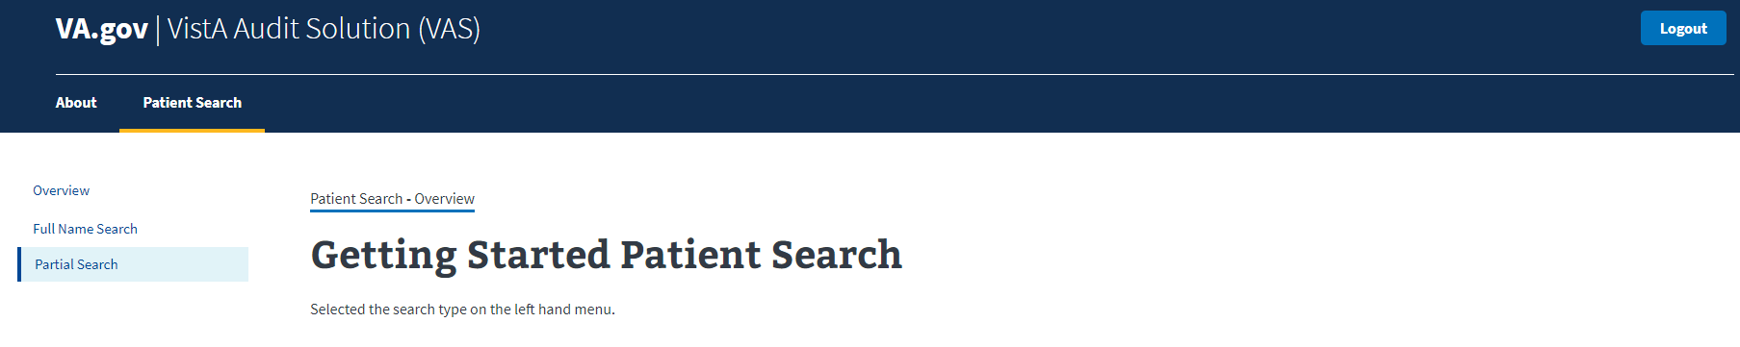
Figure 10: Partial Search Button
- The Partial Search window displays as seen below.
  - Enter the Patient’s First Initial of Last Name. *required field
  - Enter the Last 4 digits of the Patient’s SSN. *required field
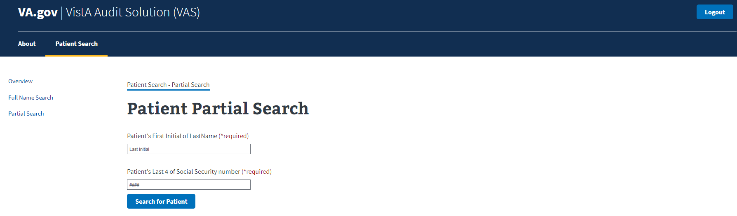
Figure 11: Patient Partial Search Page
- Once the required fields have been entered, the Search for Patient button will be enabled.
  - The Search for Patient button will remain disabled if the search criteria is entered incorrectly or left blank.
- Click Search for Patient.

Single Patient Results – Partial Search
The patient search information will display on the screen when the results are for a single record. This includes the patient’s name, date of birth, and social security number. A drop-down list labeled User Name will display below the patient’s information. This list contains the individuals within the VistA environment that have accessed the patient’s record. The New Search button above the patient’s information will allow the user to start a new search.
Figure 12: Patient Partial Search - Single Patient Results

Multiple Patient Results – Partial Search
When multiple results are returned, click the Select Patient button for the desired Patient’s record.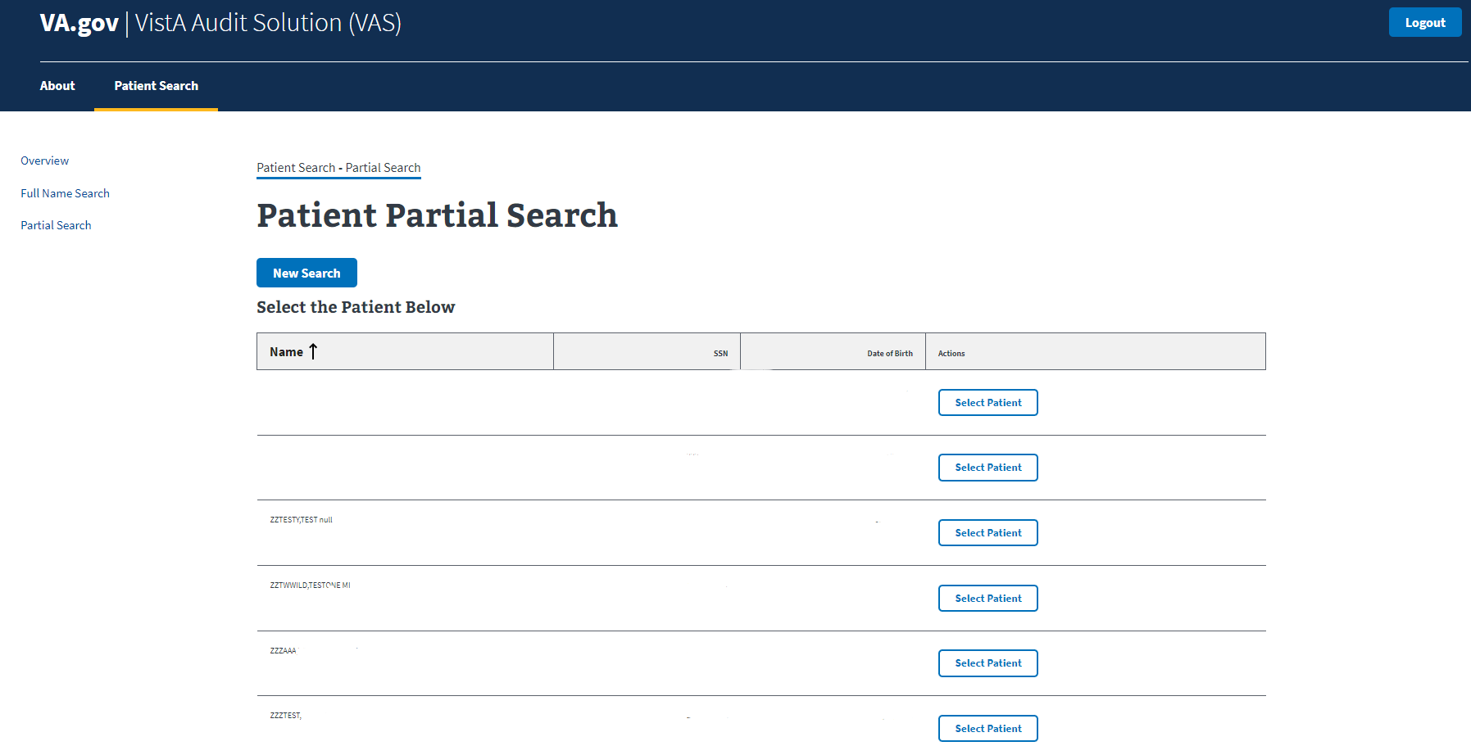
Figure 13: Patient Partial Search - Multiple Patient Results

No Patient Results – Partial Search
The screen will not display any patient information if the search criteria entered cannot locate a record. The user should verify that they correctly entered the search data when performing the Partial Search function. The New Search button will display in the case that the user would like to perform a new search.
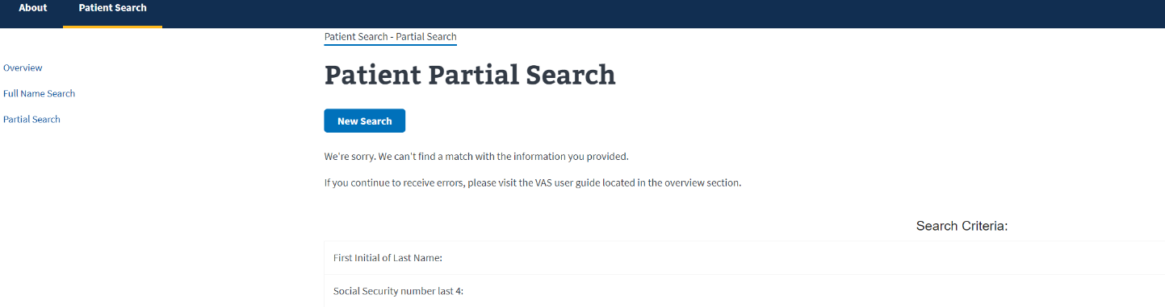
Figure 14: Partial Search – No Patient Results

User Search
Once a patient record is chosen from a Full or Partial Search, a User search may be conducted by clicking the User Search button. The User Name drop-down list will appear, as well as the Print User List button. The User Name drop-down list contains the individuals within the VistA environment that have accessed the patient’s record. The New Search button above the patient’s information will allow the user to start a new search.
Figure 15: User Search

Print User List
The user name list may be printed at any point from a patient search result. Click on the Print User List button below the User Name drop-down menu and follow your local computer’s printing procedures.
Figure 16: Print User List

Steps to Select a User
- Click the drop-down arrow for the User Name menu.
The User Name drop-down menu will contain the names of the users who have accessed the Patient’s records.
Figure 17: User Name Drop-Down Menu
- Click on the desired user name.

Metadata Records for User Search
Once the desired user name is selected the corresponding Metadata Records for the Patient record accessed by the user are displayed in groups of 10 lines (default).
- Each line includes:
  - Field Changed – the field that has been updated for the record, when appropriate.
  - Request Type – the type of action taken to the record.
    - Create: New record created.
    - Inquiry: Record has been viewed.
    - Update: Field within the record that has been updated. Includes actions to add new data, change data and delete data.
  - Date – the date and time the action was taken within VistA.
  - Site data accessed from – the VistA site where the data was accessed.
  - Actions – an Open Record button for each record available that expands and collapses more information for the selected record.
Figure 18: Metadata Records View

Date Range Search
Once a patient record is chosen from a Full or Partial Search, a Date Range search may be conducted by clicking the Date Range Search button. A Start Date field and End Date field will appear. Enter the desired date range within the Start Date and End Date fields to search for records of all users for that given patient within that timeframe.
Figure 19: Date Range Search

Steps to Enter a Date Range
- Click Date Range Search button.
- Enter a desired start date in Start Date field in MM/DD/YYYY format.
- Enter a desired end date in End Date field in MM/DD/YYYY format.
- Click Search. Metadata Records for the given timeframe for all users will display.

Metadata Records for User Search
Once the desired date range is selected the corresponding Metadata Records for the Patient record accessed by all users in that date range are displayed in groups of 10 lines (default).
- Each line includes:
  - User – name of user that accessed the patient’s information
  - Field Changed – the field that has been updated for the record, when appropriate.
  - Request Type – the type of action taken to the record.
    - Create: New record created.
    - Inquiry: Record has been viewed.
    - Update: Field within the record that has been updated. Includes actions to add new data, change data and delete data.
  - Date – the date and time the action was taken within VistA.
  - Site data accessed from – the VistA site where the data was accessed.
  - Actions – an Open Record button for each record available that expands and collapses more information for the selected record.

Search Metadata Records
- The User can filter the results of the Field Changed field.
  - All Metadata records for a Patient/User are searched with criteria entered, not just the rows displayed on the screen.
  - The example below is a search with the criteria of ‘IN’ entered and all results being displayed.
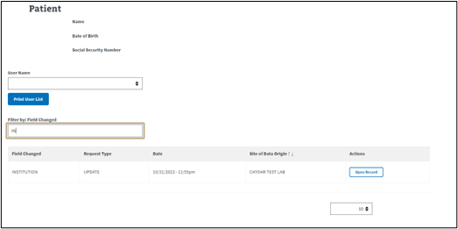
Figure 20: Searching Metadata

Navigate Metadata Records
VAS contains functionality that allows the user to navigate through the data provided in several ways.

Page Forward/Backward
In cases where the metadata records exceed 10 rows (default page size), the user can use the Next > and backward <Prev buttons at the bottom of the screen to navigate through the lines of records.
Figure 21: Metadata Record Navigation

Rows Per Page
The default page size for the display of rows of Metadata records is 10 per page. The user may increase this to 25, 50, or 100 rows per page.
- Click on the drop-down menu in the bottom right corner of the screen that shows the default number of rows (10).
- Select the number of rows desired.
  - The Rows per page will return to the default of 10 per page once another Patient is selected.
Figure 22: Change Rows Per Page

Ascending/Descending Sort
The Site of Data Origin column heading for the Metadata Records may be sorted in Ascending or Descending order by clicking on the arrows to the right of the header title.
Sort Order:
- Ascending Order: Smallest to largest; A to Z or 0 to 9
- Descending Order: Largest to smallest; Z to A or 9 to 0
Figure 23: Ascending/Descending for Site of Data Origin

Select/View Audit Record
Viewing data from selected audit records provides information about the VistA user who accessed the record, the updates and inquiries made, as well as the date and time these actions were performed. The major functions for Select/View of Audit Records are:
- View the description, from the VistA Data Dictionary, of the Field Changed.
- View Audit Record details regarding the actions taken in VistA for the Patient Record.

Audit Record Fields
When clicking the Open Record button for a row in the Metadata Record table, the audited data information expands as shown below.
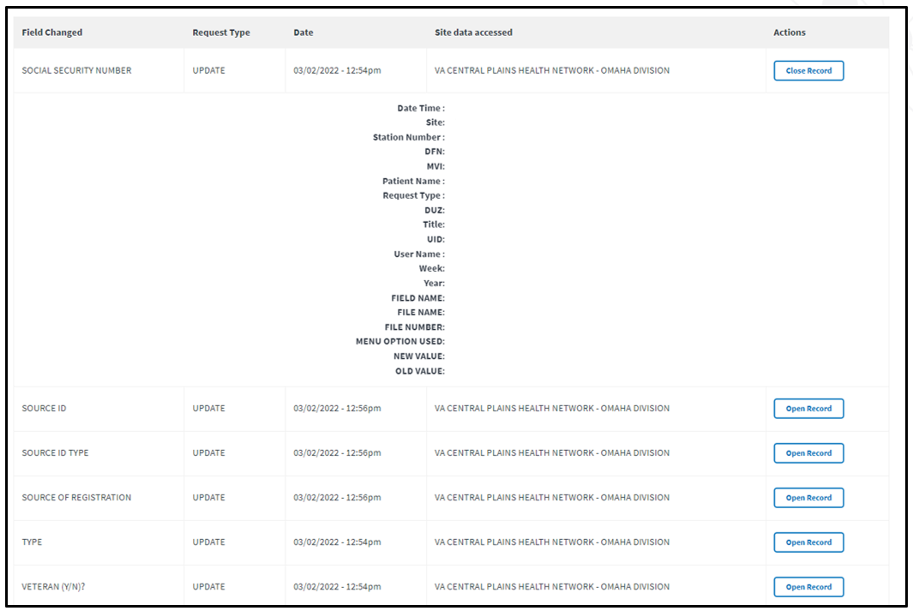
Figure 24: Opened Record from Metadata Record
Each Audit Record contains the fields below. The fields are populated with data specific to the selected record.
- Date/Time: Date and Time that the field was accessed by the chosen VistA site User.
- Site: VistA Site where the record resides, and action was taken.
- Station #: Station ID where the record resides, and action was taken.
- DFN: Data File Number (DFN) is the Internal Entry Number (IEN) in the PATIENT file (#2).
- MVI: Master Veteran Index (MVI) is the authoritative source for person identity data. Maintains identity data for persons across VA systems, a unique universal identifier for each person.
- Patient Name: Patient Name for record selected.
- User Name: The Name of the VistA user that took the action at the VA site for the Patient record.
- Request Type: The type of request that was done for the selected record. Request types include Create, Update, and Inquiry.
- DUZ: DUZ is the user number that refers to the Internal Entry Number (IEN) of the logged-on user for the local VistA system.
- Title: User Title is the position title for the VistA user.
- UID: Unique User ID (UID) is the unique identifier for the VistA user by Security ID. This field is also known as the SECID for VA Single Sign-On (SSOi).
- Week: Displays the calendar week number that the Audit Record action occurred.
- Year: Displays the calendar year that the Audit Record action occurred.
- Field Name: The name of the field for the action taken in VistA.
- Menu Option Used: Name of the menu option utilized by the VistA user to Create, Update, or Inquire for the selected record.
- New Value: The value that the VistA user updated or added to the audited field.
- Old Value: The value in the field prior to the update action. If there was no old value, the field will be populated with <no previous value>.
The Open Record button becomes the Close Record button when the record is expanded and can be clicked to collapse the record.

Logout/Close/Exit VAS UI

Logout
Clicking the Logout button in the top right corner of the VAS UI page will log the user out of VAS. The user will be brought to the VA Single Sign-On logout page and a message will read You have been logged out of Vista Audit Solution (VAS).
Figure 25: Logout Button for VAS

Close/Exit
Closing the UI browser will exit the user from the VAS application. Below are a few ways this may be accomplished.
- In Chrome or Edge, the keyboard shortcut, Alt + F4, will quickly close the active window and all open windows.
- Click the ‘X’ located on the right side of the VistA Audit Solution tab. This will close the browser.
Figure 26: Exit VAS UI
- To close all tabs in Chrome or Edge, click the ‘X’ located in the far upper right corner.
Figure 27: Close Browser

Troubleshooting

VAS is Unresponsive
Unresponsive behavior can occur with a session timeout or loss of network connectivity. Input entered prior to a loss of connectivity or timeout will not be saved or recoverable. Refreshing the page may keep you on the same page if a timeout occurs, but you may be re- prompted for the PIN for your PIV.
Session timeout will occur when PIV cache is expired on the browser. The PIV dialog will be shown and require PIN entry.

Contact VAS Team
For additional support and information, contact the VAS Support team using the email group available in the VA Global Address List (GAL) as displayed below.
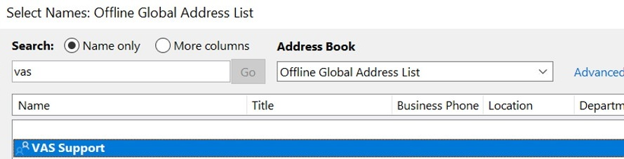
Figure 28: VA Global Address List

Appendix A: Acronyms and Abbreviations
Term | Definition
API | Application Programming Interface
AWS | Amazon Web Services
CRUD | Creation, Retrieval, Updating, and Deletion
DFN | Data File Number
DG | Registration package
GAL | Global Address List
HIPAA | Health Insurance Portability and Accountability Act
IEN | Internal Entry Number
IG | Inspector General
ISSO | Information Systems Security Officer
MVI | Master Veteran Index
OIT | Office of Information and Technology
PHI | Protected Health Information
PII | Personally Identifiable Information
PIN | Personal Identification Number
PIV | Personal Identification Verification
REST | Representational State Transfer
SSOi | Single Sign-On Integration
UI | User Interface
UID | Unique User ID
URL | Uniform Resource Locator
VA | Department of Veterans Affairs
VAS | VistA Audit Solutions
VAEC | Veterans Affairs Enterprise Cloud
VAMC | Veterans Administration Medical Center
VistA | Veterans Information System and Technology Architecture

